USC Air POwered Rover

Subject:  Related Subjects: | Grade Level(s):  Length of Lesson: | Type: Inquiry / Design / Project  Keywords:

Lesson Overview
Use this section to describe at a high level what the lesson is. Should be no more than 3-4 lines.

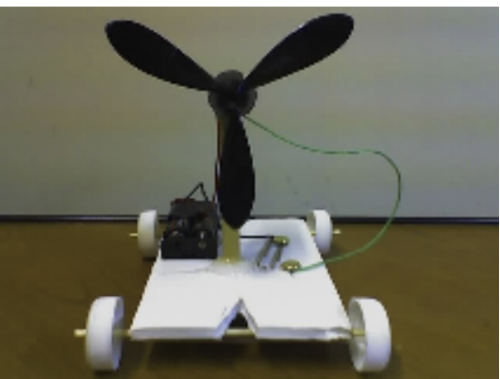

Lesson Focus
Each group will create an air powered car and then test cars for speed and
accuracy

Lesson Objective(s) | • Students build suspension (wheels and axles) from bottle caps, foam core  and wood dowels.  • Students build chassis from foam core.  • Students create series circuit with motor, batter holder and switch  • Students assemble USC air rover.  • Students determine which design leads to better performance in  • Speed  • Direction

Lesson Timing

5 minutes | Introduce the Lesson
30 minutes | ...

Materials | - 1. –Foam board  - 2. –Wood skewers  - 3. –Two straws  - 4. – 1⁄4” wood dowels  - 5. –Four caps  - 6. –1.5V  - 7. –Battery holder (double AA battery holder)  - 8. –Two AA batteries  - 9. –Brass plated fasteners  - 10.–Insulated wire  - 11. –Hot Glue gun  - 12. –Hot glue sticks  - 13.–Large paper clips  - 14.–Wire stripper  - 15.–Xacto knife  - 16.–Drill  - 17.–Propeller
Instructor Prep | - Step 1
Related Resources | - List related lessons/ppts etc available from USC or outside, trusted orgs

Lesson Plan

Introduction
The suspension of the rover comprises two straws, two wood skewers and four small water bottle caps. Each wood skewer is inserted lengthwise through the straw with a foam core wheel base attached to each of the
straws. A tight suspension involves a tight fit through the foam core base for the dowel. A loose suspension allows wiggle room for the dowel inside the foam core base.
The chassis of the rover has to be:

1. Sufficiently thick to carry the weight of the motor, switch, and battery
holder.
2. Sufficiently long to accommodate front and back wheels.
3. Sufficiently sturdy to withstand the force of the propeller and wheels.

The variables to this design are in chassis length and width, suspension, and
placement of the motor.

Procedure
List the steps of the activity. Remember to focus on leading students to the solution, rather than just telling them what to do. Include pictures of steps if you have them. Be sure to include some steps for discussion and reflection.

- Step 1

Wrap-up
End the lesson with some final discussions about what students designed/discovered. Connect their activity back to the focus question/problem, real world examples, and STEM careers.

Also include notes about any special cleanup considerations

Lesson Background for Teachers

Safety Procedures
• Caution should be exercised with cutting utensils (scissors, X-acto
blade).
• Students should be careful with hot surfaces (glue gun, soldering iron).
• Proper safety procedures and equipment should be used for drill, drill
press and belt sander.

